Ideation Phase

Define the Problem Statements

| Date | 10 September 2022 |
| --- | --- |
| Team ID | PNT2022TMID48482 |
| Project Name | Project - Personal Expense Tracker Application |
| Maximum Marks | 2 Marks |

# Customer Problem Statement Template:

Create a problem statement to understand your customer's point of view. The Customer Problem Statement template helps you focus on what matters to create experiences people will love.

A well-articulated customer problem statement allows you and your team to find the ideal solution for the challenges your customers face. Throughout the process, you’ll also be able to empathize with your customers, which helps you better understand how they perceive your product or service.

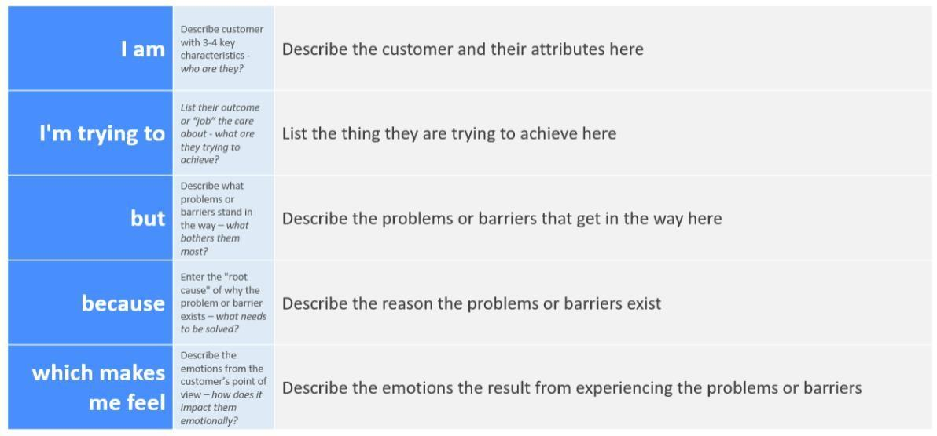

# Personal Expense Tracker Application:

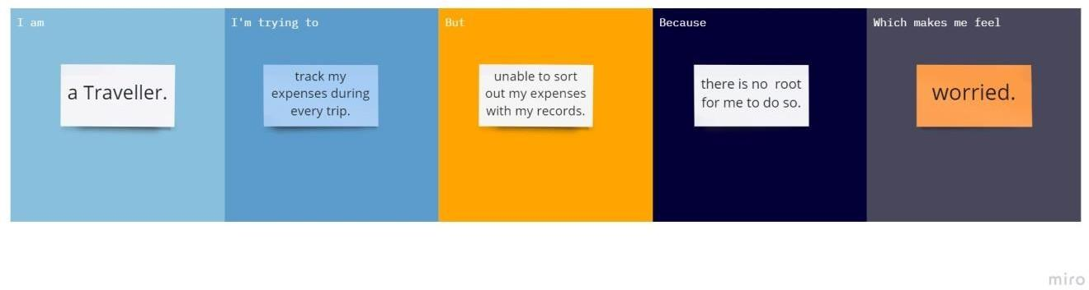

| **Problem Statement (PS)** | **I am (Customer)** | **I’m trying to** | **But** | **Because** | **Which makes me feel** |
| --- | --- | --- | --- | --- | --- |
| PS-1 | an employee. | Make a monthly budget. | There are no facilities to set a  budget. | I need to save money for my future plans. | Frustrated. |
| PS-2 | A manager. | Keep track of my expenses. | Can’t categorize the various types of  expenses. | There is no option to organize the various expenses. | Uncomfortable. |